FFT Experiments

# 1728 bit – QPSK >> 864 complex symbols

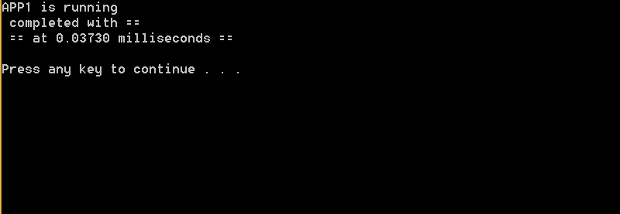

Figure 1: Random sample of 1D Function duration for 6 RBs QPSK

# 86400 bit – 64QAM >> 14400 symbols

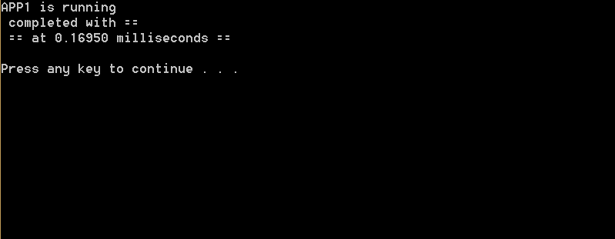

Figure 2: Random sample of 1D Function duration for 100 RBs 64QAM

## Note That:

Samples for the extreme case (100 RBs) = **[0.12ms: 0.35ms]**

Project Name: FFT_EXP